ANNEX B
Suggested changes for the ADF II CDP CMT training manual
- A chart showing the business cycle should be presented and explained to give better insight into how a business is run. See sample below, this can be tailored by each CDP.
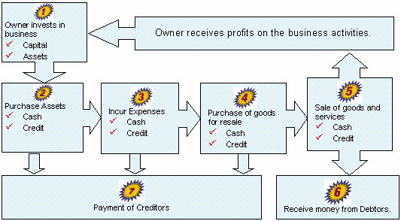

- Research could be done on exercises that display the meaning of leadership, entrepreneur, proactive and all other relevant words.
- More exercises should be added and completed during each training to facilitate a more hands-on approach to understanding their roles as CMT members.
- Exercises currently in the manual should be carried out and completed.
- The manual should be more user friendly. Simple language should be highly considered means of communicating.
- Sample bills should be created to show fully the level of detail required to keep records.
- A template company should be created and exercise given to work out the steps of processing and recording payments and receipt of funds (cash, cheque or otherwise) and all relevant documentation
- All depictions should be clear, readable and comprehensive. Particular attention should be paid to reducing grammatical and spelling errors as this may reduce the probability of full comprehension to the CMT members.
- GANTT chart, workplan, cash book, narrative report and CDP financial report should be done in template form and explained with a sample company.
Prepared by:
___________________________
Shonelle Chase-Wishart
Date: ______________________

